**Website Blocker**

Submitted in partial fulfillment of the requirements of the degree.

**BACHELOR OF ENGINEERING** in **INFORMATION TECHNOLOGY**

By

**SAKSHI GAUL : (70)**

**NIKITA GUPTA : (71)**

**VAISHNAVI RAJPUT : (75)**

Under the Guidance

**Prof. P. A. Patel**



**Department of Information Technology**

**Bharati Vidyapeeth’s College of Engineering, Kharghar, Navi Mumbai - 400614 University of Mumbai**

**(AY 2020-21)**

# CERTIFICATE

This is to certify that the Mini Project entitled “ **Website Blocker”** is a bonafide work of **SAKSHI GAUL(70), NIKITA GUPTA(71), VAISHNAVI**

**RAJPUT (75)** submitted to the University of Mumbai in partial fulfillment of the requirement for the award of the degree of **“Bachelor of Engineering”** in **“Information Technology” .**

### Prof. P. A. Patel

### Project Guide

### Prof. H. B. Sale Dr. S. D. Jadhav

Head of Department Principal

# Mini Project Approval

This Mini Project entitled “Website Blocker**”** by **SAKSHI GAUL(70), NIKITA GUPTA(71), VAISHNAVI RAJPUT(75)** is approved for the degree of **Bachelor of Engineering** in **Information Technology.**

## Examiners

**1………………………………………**

(Internal Examiner Name & Sign)

### 2…………………………………………

(External Examiner name & Sign)

# Contents

### Abstract i

### Acknowledgments ii

### List of Figures iii

### Introduction 1

* 1. Introduction
  2. Motivation
  3. Problem Statement & Objectives
  4. Organization of the Report

### Literature Survey 11

* 1. Survey of Existing System
  2. Limitation Existing system or research gap
  3. Mini Project Contribution

### Proposed System (eg: New Approach of Data Summarization) 18

* 1. Introduction
  2. Architecture/ Framework
  3. Flowchart
  4. Details of Hardware & Software
  5. Experiment and Results
  6. Conclusion and Future work.

### **ABSTRACT**

The project titled “**Website Blocker**” is designed with Phyton IDE. We are going to develop python application which will block a certain website (whatever website you want- Facebook, YouTube etc.) during certain hours of the day (9:00 to 18:00 hours), consider office hours of the day, we want to blocks all social networking sites. We are going to use the python built-in libraries, so no need to install any Third-Party packages. Every operating system has a hosts file. Location of the host file may be different for the different operating system. This host file is map hostname to IP address of the machine. In this host file, we going to list websites which we want to block. As I have not mentioned, any website name in my host file. If I try to open “youtube.com”, I can do it without any problem. Below is the screenshot (just to make sure after running my scripts, this website shouldn’t open if I want to block it.) We can customize above code as per our requirement like duration, websites, custom messages etc.

**Acknowledgments**

First, I would like to thank my lecturer Mr. PRAVEEN PATEL for helping me to acquire some basic knowledge of “Python Programming Language”.

At the same time, he gave me the opportunity to learn something new related to our module like constructors, methods, arrays etc.

Beside from my lecturer, I like to thank my other teammates for helping to understand the assignment related questions more clearly. They gave their best for completing this report on time. I thank them for their efforts.

**List of Figures**

Figure 1: The system architechture

Figure 2: Result

Figure 3: Flowchart

Figure 4: code

Figure 5: code

Figure 6: code

Figure 7: code

**INTRODUCTION**

The project is “Website Blocker ” software for Blocking particular website in working time. If you are working in a big IT company then you may notice that their couple of websites are blocked especially social networking sites like Facebook, YouTube, Instagram etc. Instead of using third-party applications to blocks certain website, we can develop our own custom application which will block websites of our choice and developing a website blocker in python is not so difficult too. That’s what we going to do- develop a python script which will block the website .during certain hours of the day (9:00 to 18:00 hours), consider office hours of the day, we want to blocks all social networking sites. We are going to use the python built-in libraries, so no need to install any Third-Party packages. Every operating system has a hosts file. Location of the host file may be different for the different operating system. This host file is map hostname to IP address of the machine. In this host file, we going to list websites which we want to block. As I have not mentioned, any website name in my host file. If I try to open “youtube.com”, I can do it without any problem. Below is the screenshot (just to make sure after running my scripts, this website shouldn’t open if I want to block it.) We can customize above code as per our requirement like duration, websites, custom messages etc.

**MOTIVATION**

We got the motivation from the fact that if we made a “Website Blocker” it will help the When we are in working time and we don’t have any interrupt or any disturbance.

That’s what we going to do- develop a python script which will block the website .during certain hours of the day (9:00 to 18:00 hours), consider office hours of the day, we want to blocks all social networking sites.

So, its help to focus on our work and there is no any disturbance.

**Problem Statement & Objectives**

We have created a user-friendly Website Blocker system which is very easy to use and provides Excellent ability.

Nowadays everything is digital and we are always keep using social media , and to avoid to use of social media which always disturbing for us during office work so ,we decided to make a it websites which we don’t want to use during office time that keep block for particular time.

We used the Phyton language for making the website blocker system.

**Objectives :**

The main objective was to make a Website Blocker System with user friendly interface easily understandable and must be secure. And for that We need to know the following python modules to build the python website blocker.

1. **file handling:** file handling is used to do the modifications to the hosts file.
2. **time:** The time module is used to control the frequency of the modifications to the hosts file.
3. **datetime:** The datetime module is used to keep track of the free time and working time.

**ORGANISATION OF REPORT**

This report is to summarize the project in every aspect. It shows all the components such as tables, abbreviation, symbols, lists, figures, etc. It also includes the points such as the motivation, inspiration for the Website Blocking System and the problems we faced and their solutions.

The report also shows literature surveys done during the project. Further the report shows the details of the project such as the algorithm framework, system architecture, process design and the hardware and software details.

**Literature Survey**

The literature review plays a very important role in the research process. It is a source from where research ideas are draw n and developed into concepts and finally theories. It also provides the researcher a bird’s eye view about the research done in that area so far. Depending on what is observed in the literature review, a research er will understand where his/her research stands. Here in this literature survey, all primary, secondary and tertiary sources of information were searched. The study of literature on Website Blocker in general and in the field of library and information science particular revealed several efforts made by the scholars in different discipline. The purpose of the literature survey is to collect a lot of number of journal’s article about a particular topic like as I have collected articles of “Website Blocker” with abstract. The main aim of this collection is to provide a guideline and brief information of researcher, user an dot her person who want information about this topic.

**Process of Executing Concept**

To block the access to a specific website on the computer, we need to configure the **hosts** file.

### **The hosts file**

The hosts file is a local file which was used to map hostnames to IP addresses in the old days. Although the DNS service is used nowadays to map the hostnames to the IP addresses, the host file is still very complex and can be used to configure the mapping of the IP addresses locally.

### **Location of hosts file**

The location of the hosts file varies from operating system to operating system.

**Windows:** C:\Windows\System32\drivers\etc

## Configuration

Since the hosts file contains the mapping between the host names and IP addresses, let's look at the content of our hosts file first stored as **/etc/hosts** as we use CentOS 7 (Linux).

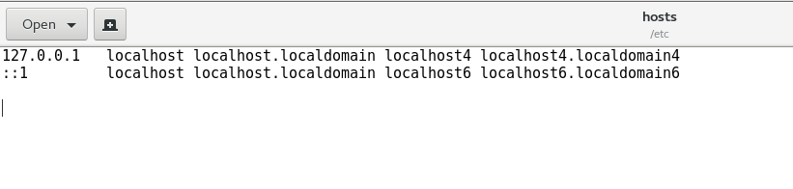

As we can see in the above image, the mappings are saved for the localhost with the IP address 127.0.0.1.

Similarly, we can redirect any hostname back to the localhost IP (127.0.0.1). It will block the access to that hostname and redirect that to localhost on each request.

For testimony, let's edit the content of hosts file and add some of the following lines to it. To make changes to the **/etc/hosts** file, we will need to change its permissions.

Run the following command on the terminal to change the permissions.

1. $ sudo chmod 777 /etc/hosts

Now add the following line to the file to block the access to facebook.com (for example).

1. 127.0.0.1       www.facebook.com

As shown in the image below.

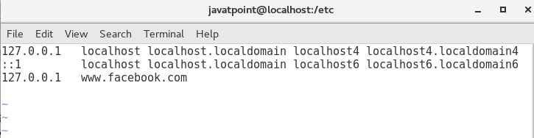

Save the file and try to open the www.facebook.com using the browser.

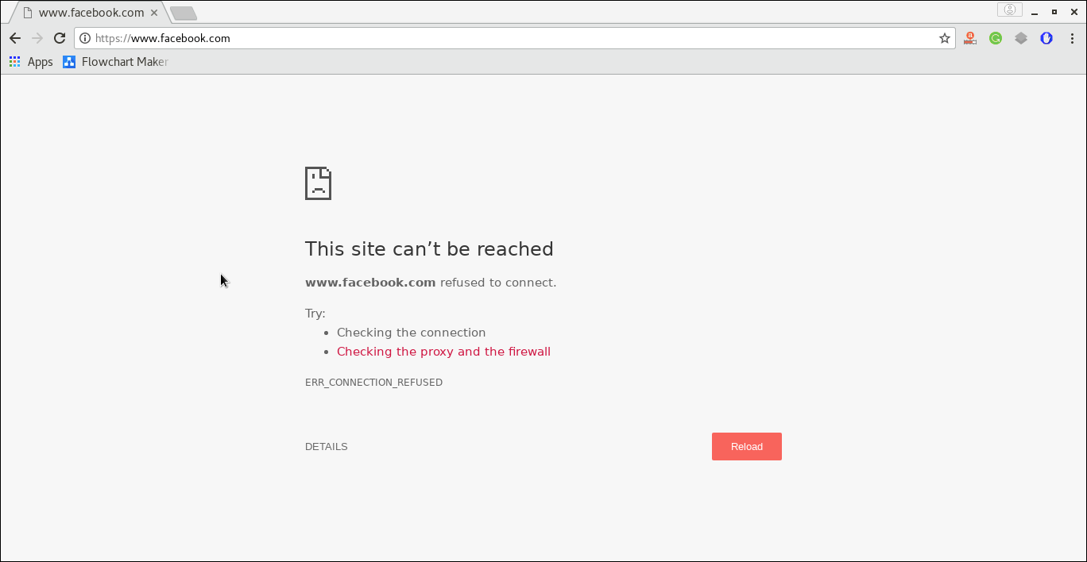

As shown in the above figure, it is refused to connect.

We have completed our task by manually editing the hosts file. We haven't achieved our objective yet. Our objective is to block access to some particular websites (for example, facebook) during working hours only (9 AM to 5 PM).

It needs a python script which keeps adding the necessary lines to the hosts file during a particular period.

**Proposed System (eg New Approach of Data Summarization)**

### Introduction

* We have created a user-friendly Website Blocker system which is very easy to use and provides Excellent ability.
* Nowadays everything is digital and we are always keep using social media , and to avoid to use of social media which always disturbing for us during office work so ,we decided to make a it websites which we don’t want to use during office time that keep block for particular time.
* We used the Phyton language for making the website Blocker System.

**ARCHITECHTURE AND FRAMEWORK**

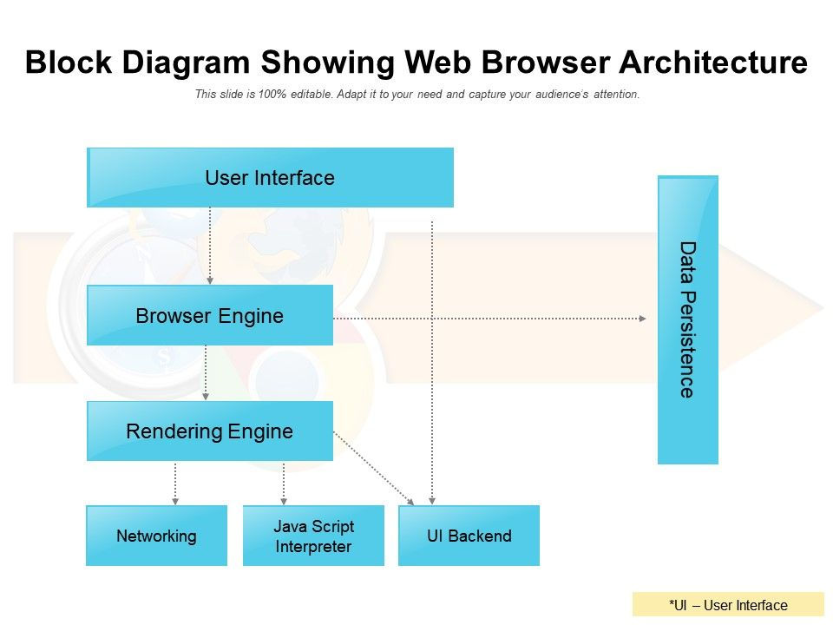

**Python-**For programming reason, we are going to utilize Python as the Programming language. Python is easy to learn and work on with the language. It is an elevated level, broadly useful programming and exceptionally intruded on language.

**Flowchart**

**Figure 2: Flowchart**

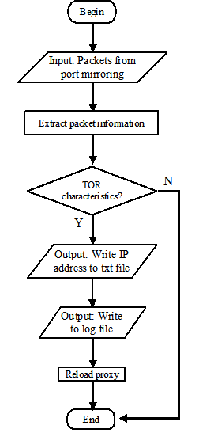

**Details of Hardware & Software**

HARDWARE REQUIRMENTS:

Processor –Intel platinum 4 or later compiler

Hard Disk-410GB or more

Ram -1GB or more

**SOFTWARE REQUIRMENTS:**

* Programming language -  Python
* Operating System - any os like a window, Mac, Linux.

**EXPERIMENT AND RESULT**

The experiment was to create a user friendly website Blocker system where user can perform all their tasks on their computer:

**Source Code:**

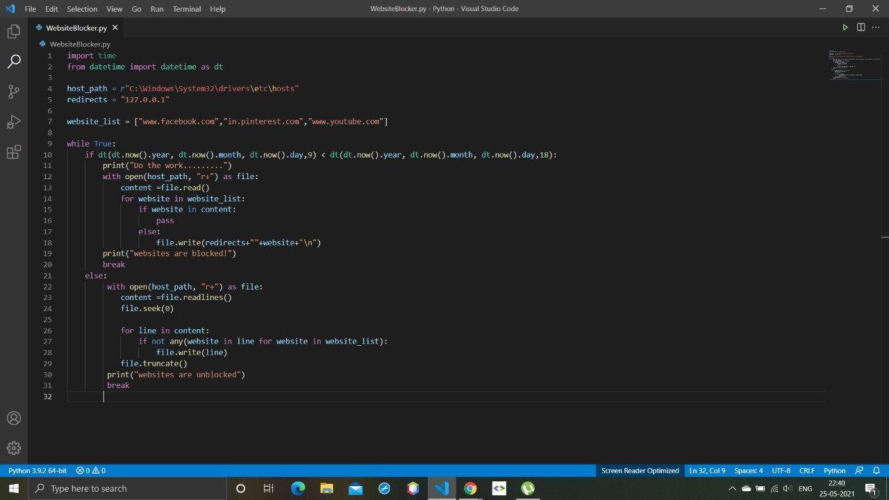

**RESULTS :**

**Figure 3: Result**

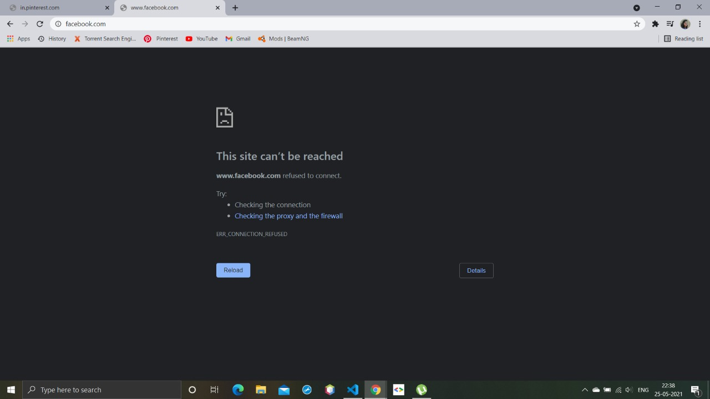

**Figure 4: code**

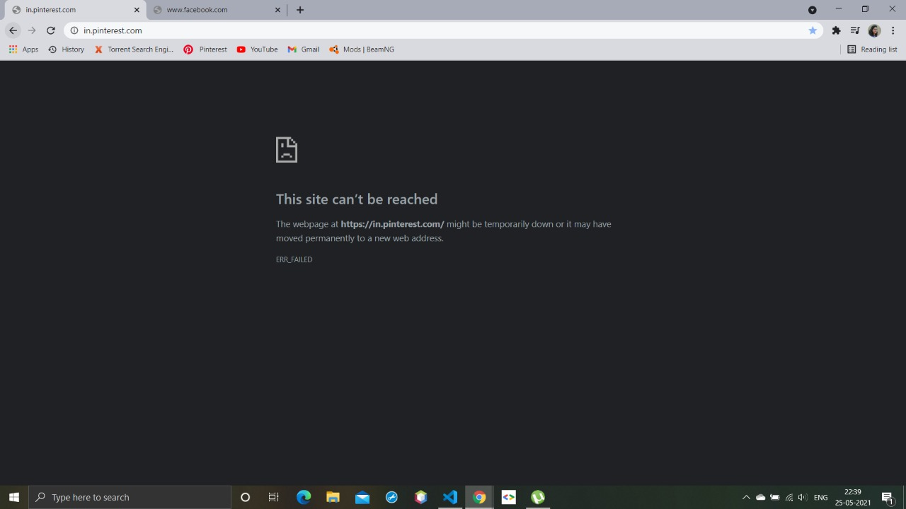

**CONCLUSION**

* After we have completed the project, we are sure the problem in the existing system world overcome.
* “Website Blocker ” software for Blocking particular website in working time.
* Nowadays everything is digital and we are always keep using social media , and to avoid to use of social media which always disturbing for us during office work so ,we decided to make a it websites which we don’t want to use during office time that keep block for particular time.
* Website Blocker is a tool that denies access to websites permanently or by schedule. To use the internet safely we can block all websites from unwanted categories.
* So, its help to focus on our work and there is no any disturbance.

**REFERENCES**

* [www.google.com](http://www.google.com/)
* [www.youtube.com](http://www.youtube.com/)
* www.geeksforgeeks.org
* [www.slideshare.com](http://www.slideshare.com/)
* Python programming- 3rd edition(John zelle)
* College Notes.